MUSIC PLAYLIST AND LISTENING STATS MANAGER
Title: Music Playlist & Listening Stats Manager | A Step-by-Step Java Project
Abstract
In our daily life, we listen to a lot of music on digital apps. Managing custom playlists and checking total listening time can be difficult if done manually. This project solves this issue by creating a simple Music Playlist & Listening Stats Manager System using Java.
This project was built step-by-step over a 6-week period. Each week, we learned and applied a new programming topic to solve one part of the system:
- Week 1: Used simple variables (int, double, String) to store song details like track lengths.
- Week 2: Used the Scanner class so the user can type in new song details from the keyboard.
- Week 3: Used if-else conditions and switch statements to check if a song is eligible for radio airplay.
- Week 4: Created an interactive menu loop using do-while so the app stays running until the user exits.
- Week 5: Created custom methods and used recursion to calculate total playback projection time.
- Week 6: Used single and 2D arrays to manage playlist track lists and count how many times each song was played.
This project shows how basic Java concepts can be combined to build a complete working command-line application.
Implementation of Java
Module 1
Week 1: Problem to Program
- Concept: Learning primitive data types (int, double, String) and using System.out.println().
- Objective: Initialize song duration variables directly inside the code and display total playlist time.
Code:

public class Module1_Week1 {
public static void main(String[] args) {
System.out.println("--- Music Playlist Inventory ---");

int durationPop = 210;
int durationRock = 354;
int durationJazz = 180;

int totalUnits = durationPop + durationRock + durationJazz;

System.out.println("Pop Track Duration: " + durationPop + " seconds");
System.out.println("Rock Track Duration: " + durationRock + " seconds");
System.out.println("Jazz Track Duration: " + durationJazz + " seconds");
System.out.println("Total Playlist Runtime: " + totalUnits + " seconds");
}
}
Output Evidence: 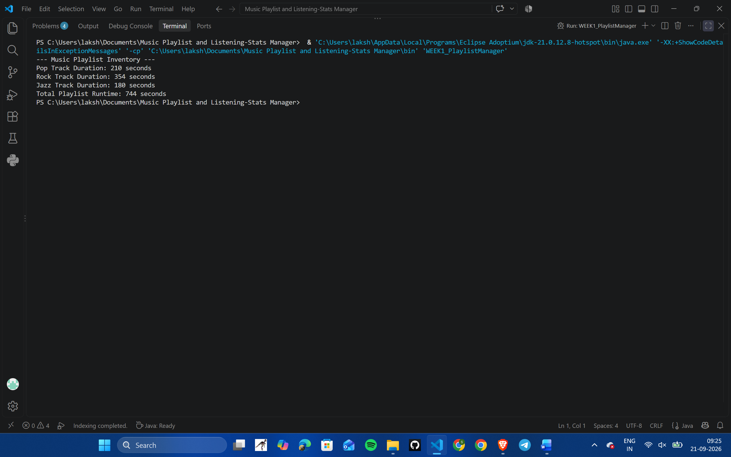

Week 2: Data Types & Scanner Intake Shell
- Concept: Taking dynamic user inputs from the console using the Scanner class.
- Objective: Allow the user to input details for a single song (title, genre, duration, and rating) from the keyboard.
Code:

import java.util.Scanner;

public class Module1_Week2 {
public static void main(String[] args) {
Scanner scanner = new Scanner(System.in);
System.out.println("=== Song Registration Shell ===");

System.out.print("Enter Song Title: ");
String songName = scanner.nextLine();

System.out.print("Enter Music Genre: ");
String genre = scanner.next();

System.out.print("Enter Duration in Seconds: ");
int duration = scanner.nextInt();

System.out.print("Enter Track Rating (1.0 to 5.0): ");
double rating = scanner.nextDouble();

System.out.println("\n--- Song Registration Summary ---");
System.out.println("Title: " + songName);
System.out.println("Genre: " + genre);
System.out.println("Duration: " + duration + " seconds");
System.out.println("Rating: " + rating + " / 5.0");

scanner.close();
}
}
Output Evidence: 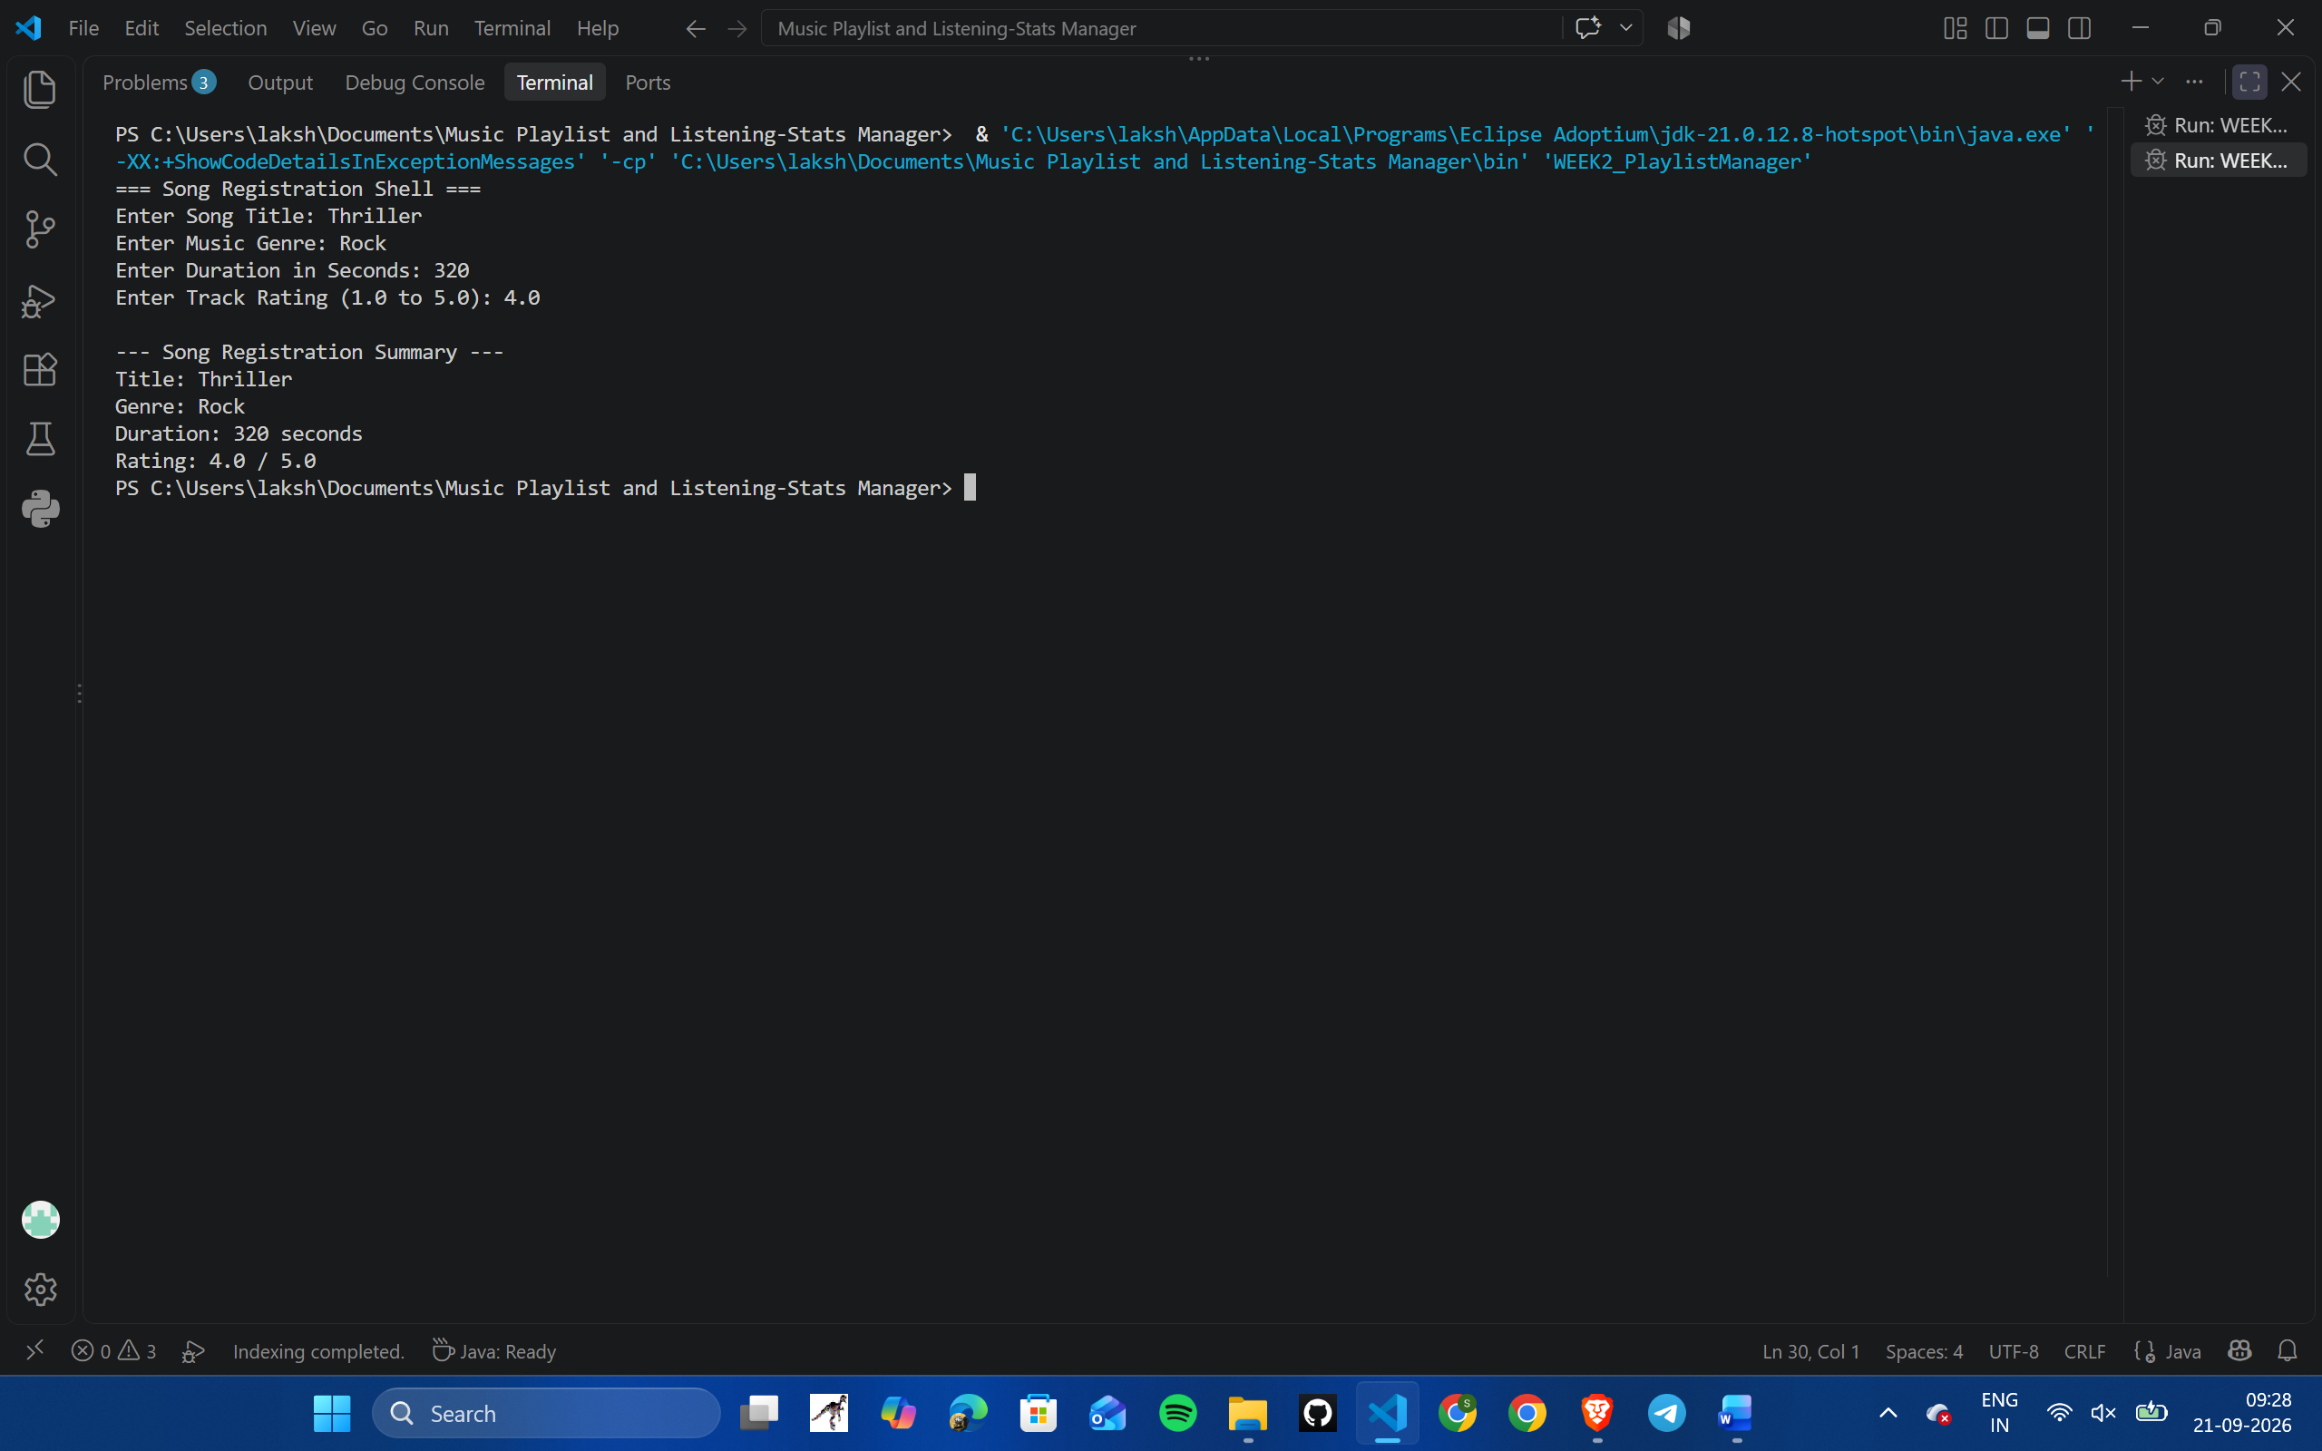

Module 2
Week 3: Selection Statements
- Concept: Using conditional decision-making statements (if, if-else, nested if, and switch-case).
- Objective: Check if a song meets duration and rating limits to qualify for airplay, and display rules for different genres.
Code:

import java.util.Scanner;

public class Module2_Week3 {
public static void main(String[] args) {
Scanner scanner = new Scanner(System.in);
System.out.println("=== Song Eligibility Check ===");

System.out.print("Enter Song Duration (seconds): ");
int duration = scanner.nextInt();

if (duration >= 60) {
if (duration <= 600) {
System.out.print("Enter Song Rating (1.0 to 5.0): ");
double rating = scanner.nextDouble();

if (rating >= 3.0) {
System.out.println("Status: Approved for Featured Playlist!");
} else {
System.out.println("Status: Rejected. Rating must be at least 3.0.");
}
} else {
System.out.println("Status: Rejected. Song length is too long (Max 600s).");
}
} else {
System.out.println("Status: Rejected. Song must be at least 60 seconds long.");
}

System.out.print("\nEnter Genre Name (POP / ROCK / JAZZ): ");
String genre = scanner.next().toUpperCase();

System.out.print("Rules for " + genre + ": ");
switch (genre) {
case "POP":
System.out.println("Radio edit format (3 to 4 mins).");
break;
case "ROCK":
System.out.println("Instrumental solos allowed.");
break;
case "JAZZ":
System.out.println("Acoustic mix active.");
break;
default:
System.out.println("Standard audio rules apply.");
break;
}
scanner.close();
}
}
Output Evidence: 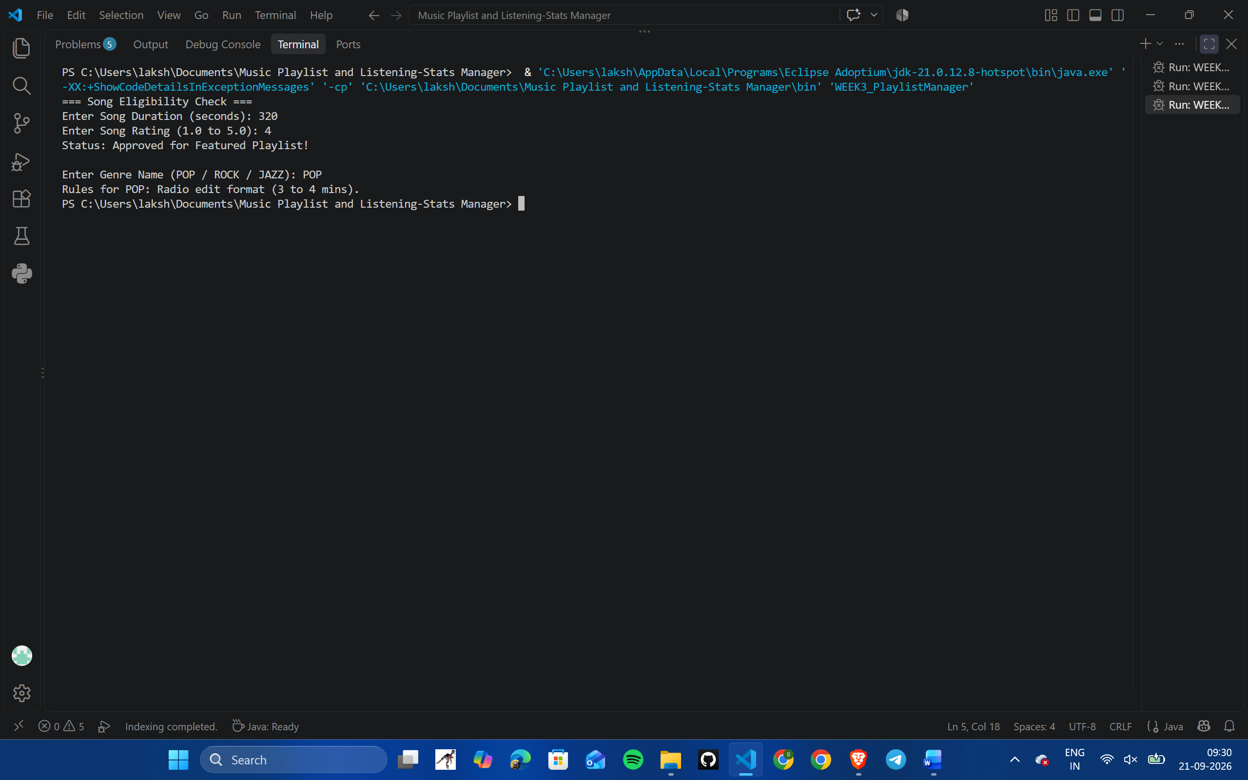

Week 4: Iteration Control Structures (Loops)
- Concept: Using loops (while, do-while, for) and control keywords (break, continue).
- Objective: Build an interactive menu system that continues to run until the user inputs the exit option.
Code:

import java.util.Scanner;

public class Module2_Week4 {
public static void main(String[] args) {
Scanner scanner = new Scanner(System.in);
int choice;

do {
System.out.println("\n--- MAIN MENU ---");
System.out.println("1. Register Song");
System.out.println("2. Play Song");
System.out.println("3. Run Diagnostic Check");
System.out.println("4. Exit");
System.out.print("Select an option (1-4): ");
choice = scanner.nextInt();

if (choice == 4) {
System.out.println("Exiting application. Goodbye!");
break;
}

switch (choice) {
case 1:
System.out.println("[LOG]: Registering a new song...");
break;
case 2:
System.out.println("[LOG]: Playing selected track...");
break;
case 3:
System.out.println("[LOG]: Running system checks...");
for (int i = 3; i > 0; i--) {
if (i == 2) {
System.out.println(" Skipping step 2...");
continue;
}
System.out.println(" Check " + i + " Passed.");
}
break;
default:
System.out.println("Invalid option! Please enter a number between 1 and 4.");
}
} while (choice != 4);

scanner.close();
}
}
Output Evidence: 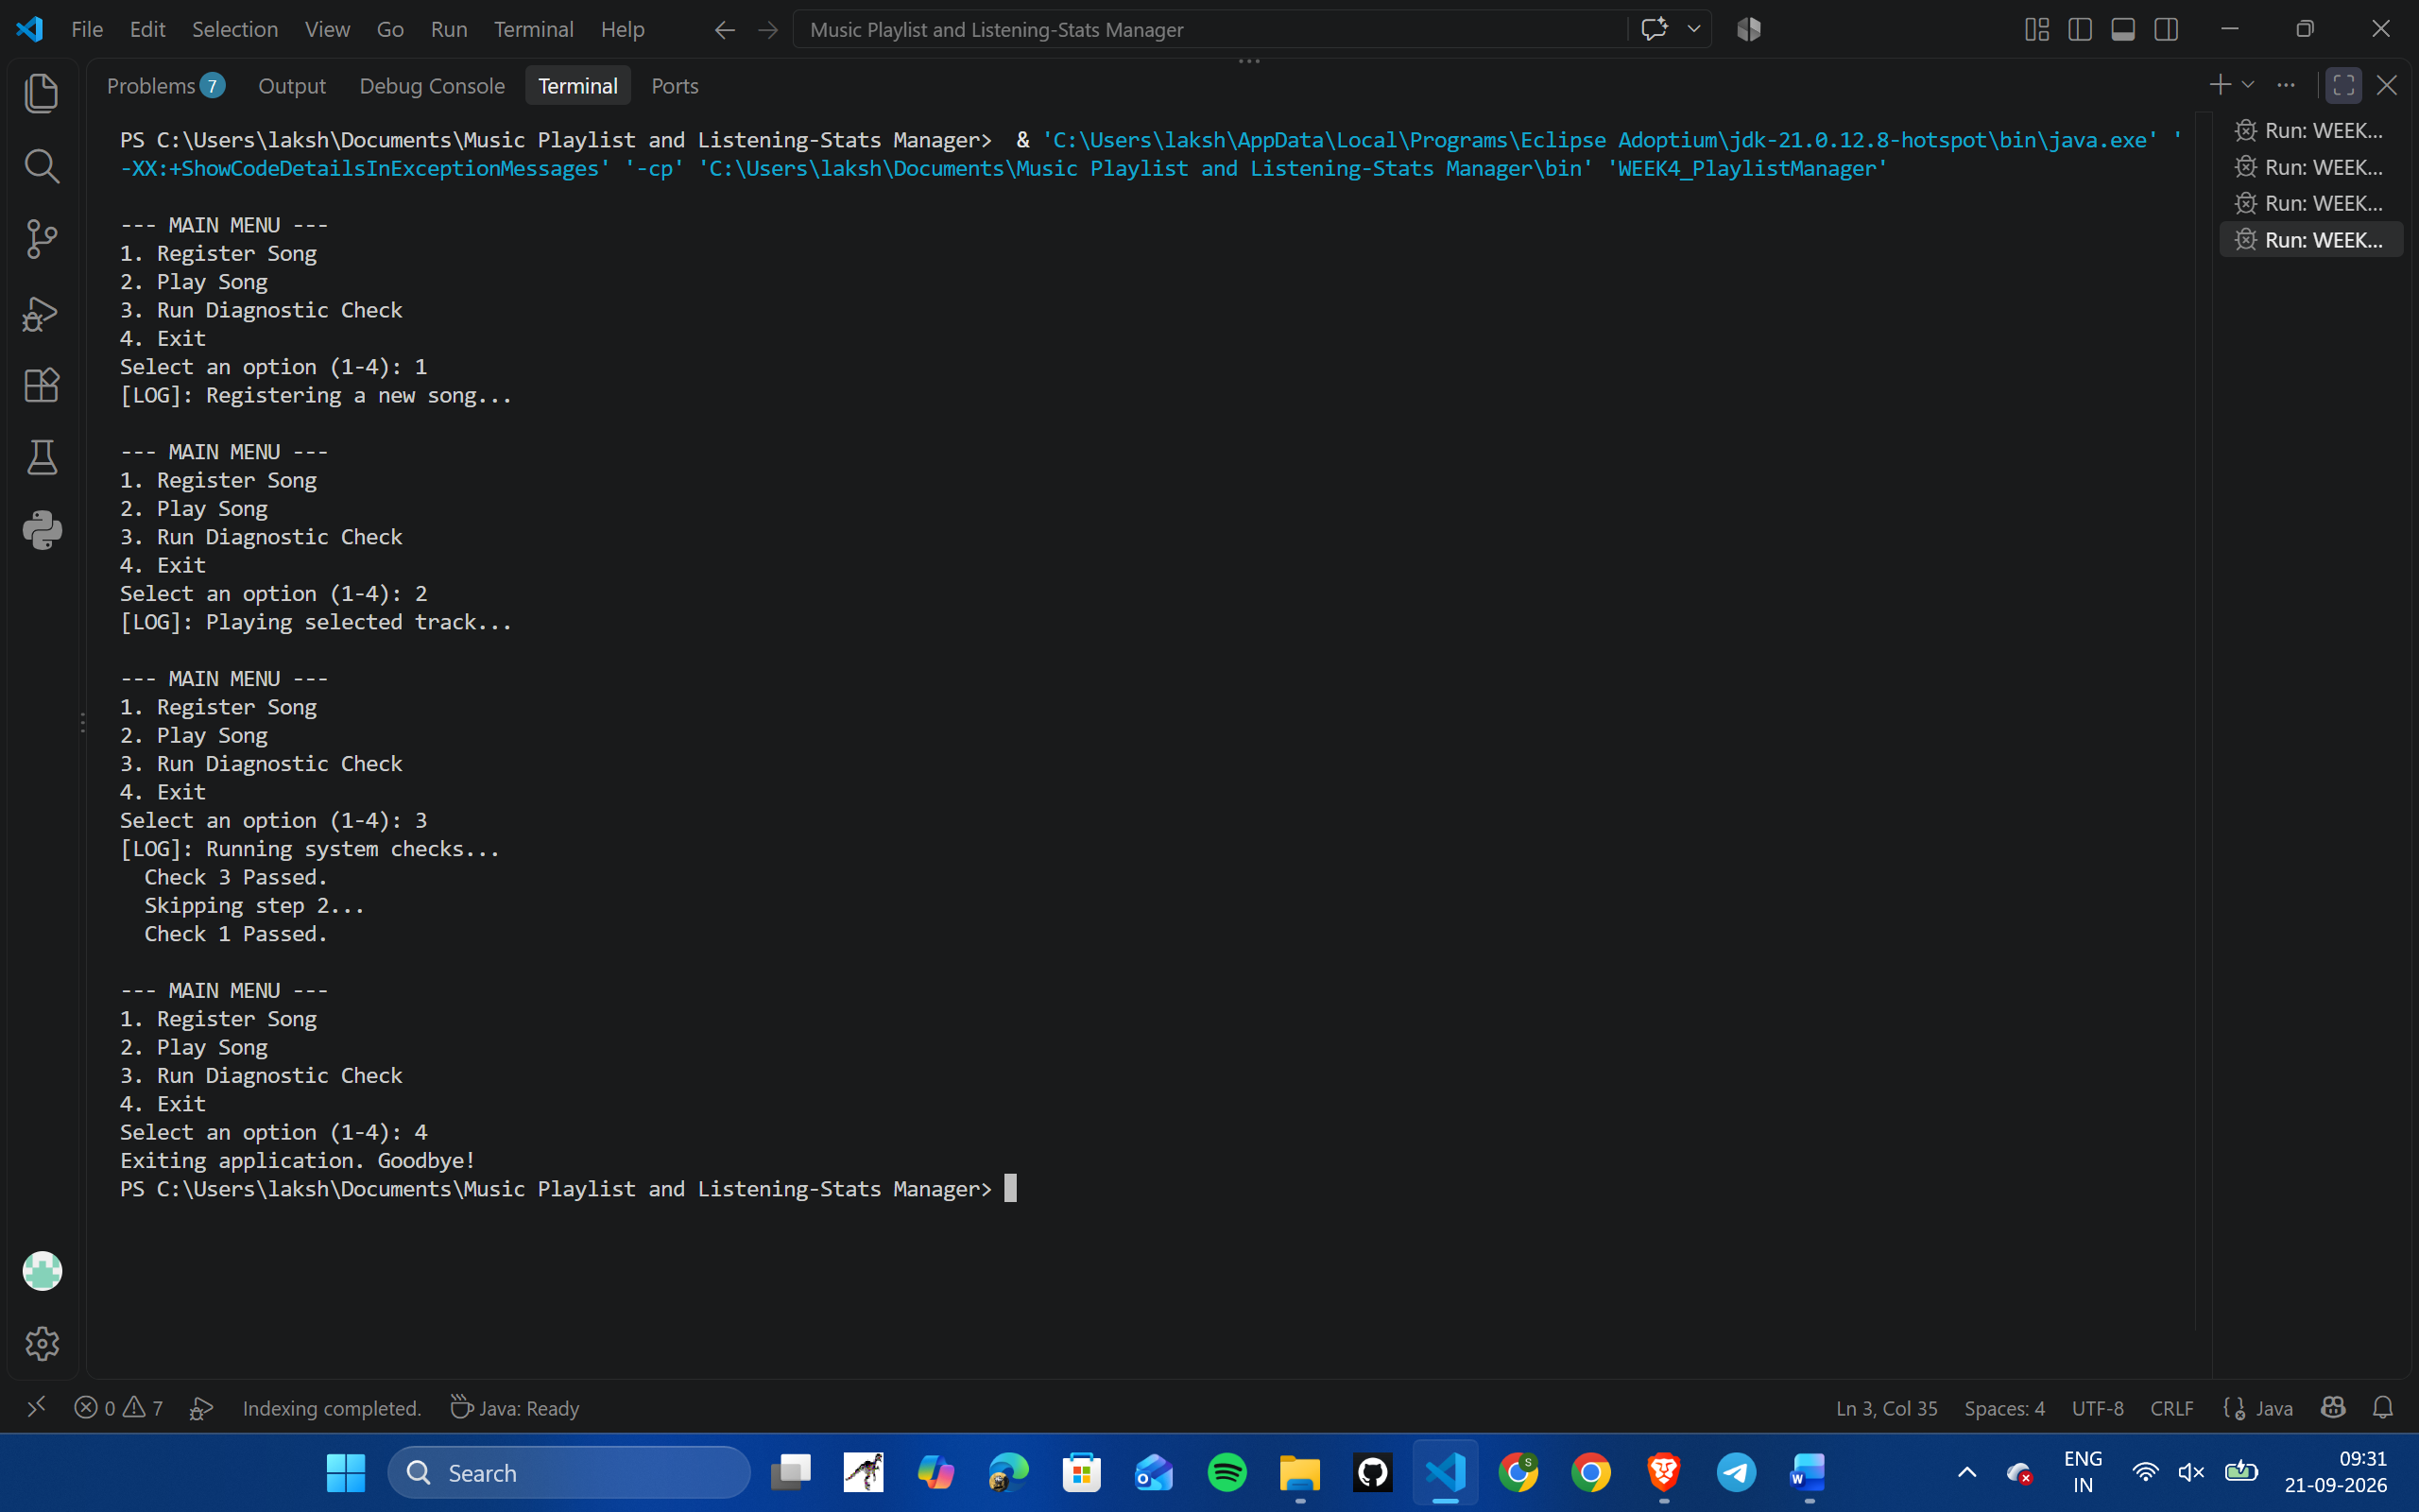

Module 3
Week 5: Methods and Recursion
- Concept: Reusable modular methods and recursive functions.
- Objective: Create a helper method to subtract song lengths from available time, and use recursion to estimate multi-level playback projections.
Code:

public class Module3_Week5 {

// Method to calculate remaining queue time
public static int subtractTime(int totalTime, int songLength) {
if (songLength > totalTime) {
System.out.println("Error: Not enough time remaining in queue!");
return totalTime;
}
System.out.println("Song added successfully.");
return totalTime - songLength;
}

// Recursive function to calculate time projection
public static int calculateProjection(int baseTime, int levels) {
if (levels <= 1) {
return baseTime;
}
return baseTime + calculateProjection(baseTime / 2, levels - 1);
}

public static void main(String[] args) {
System.out.println("=== Testing Methods and Recursion ===");

int queueTime = 3000;
queueTime = subtractTime(queueTime, 354);
System.out.println("Remaining Queue Time: " + queueTime + " seconds.");

System.out.println("\n--- Recursive Calculation ---");
int projectedTime = calculateProjection(300, 3);
System.out.println("Projected Playback Duration: " + projectedTime + " seconds.");
}
}
Output Evidence: 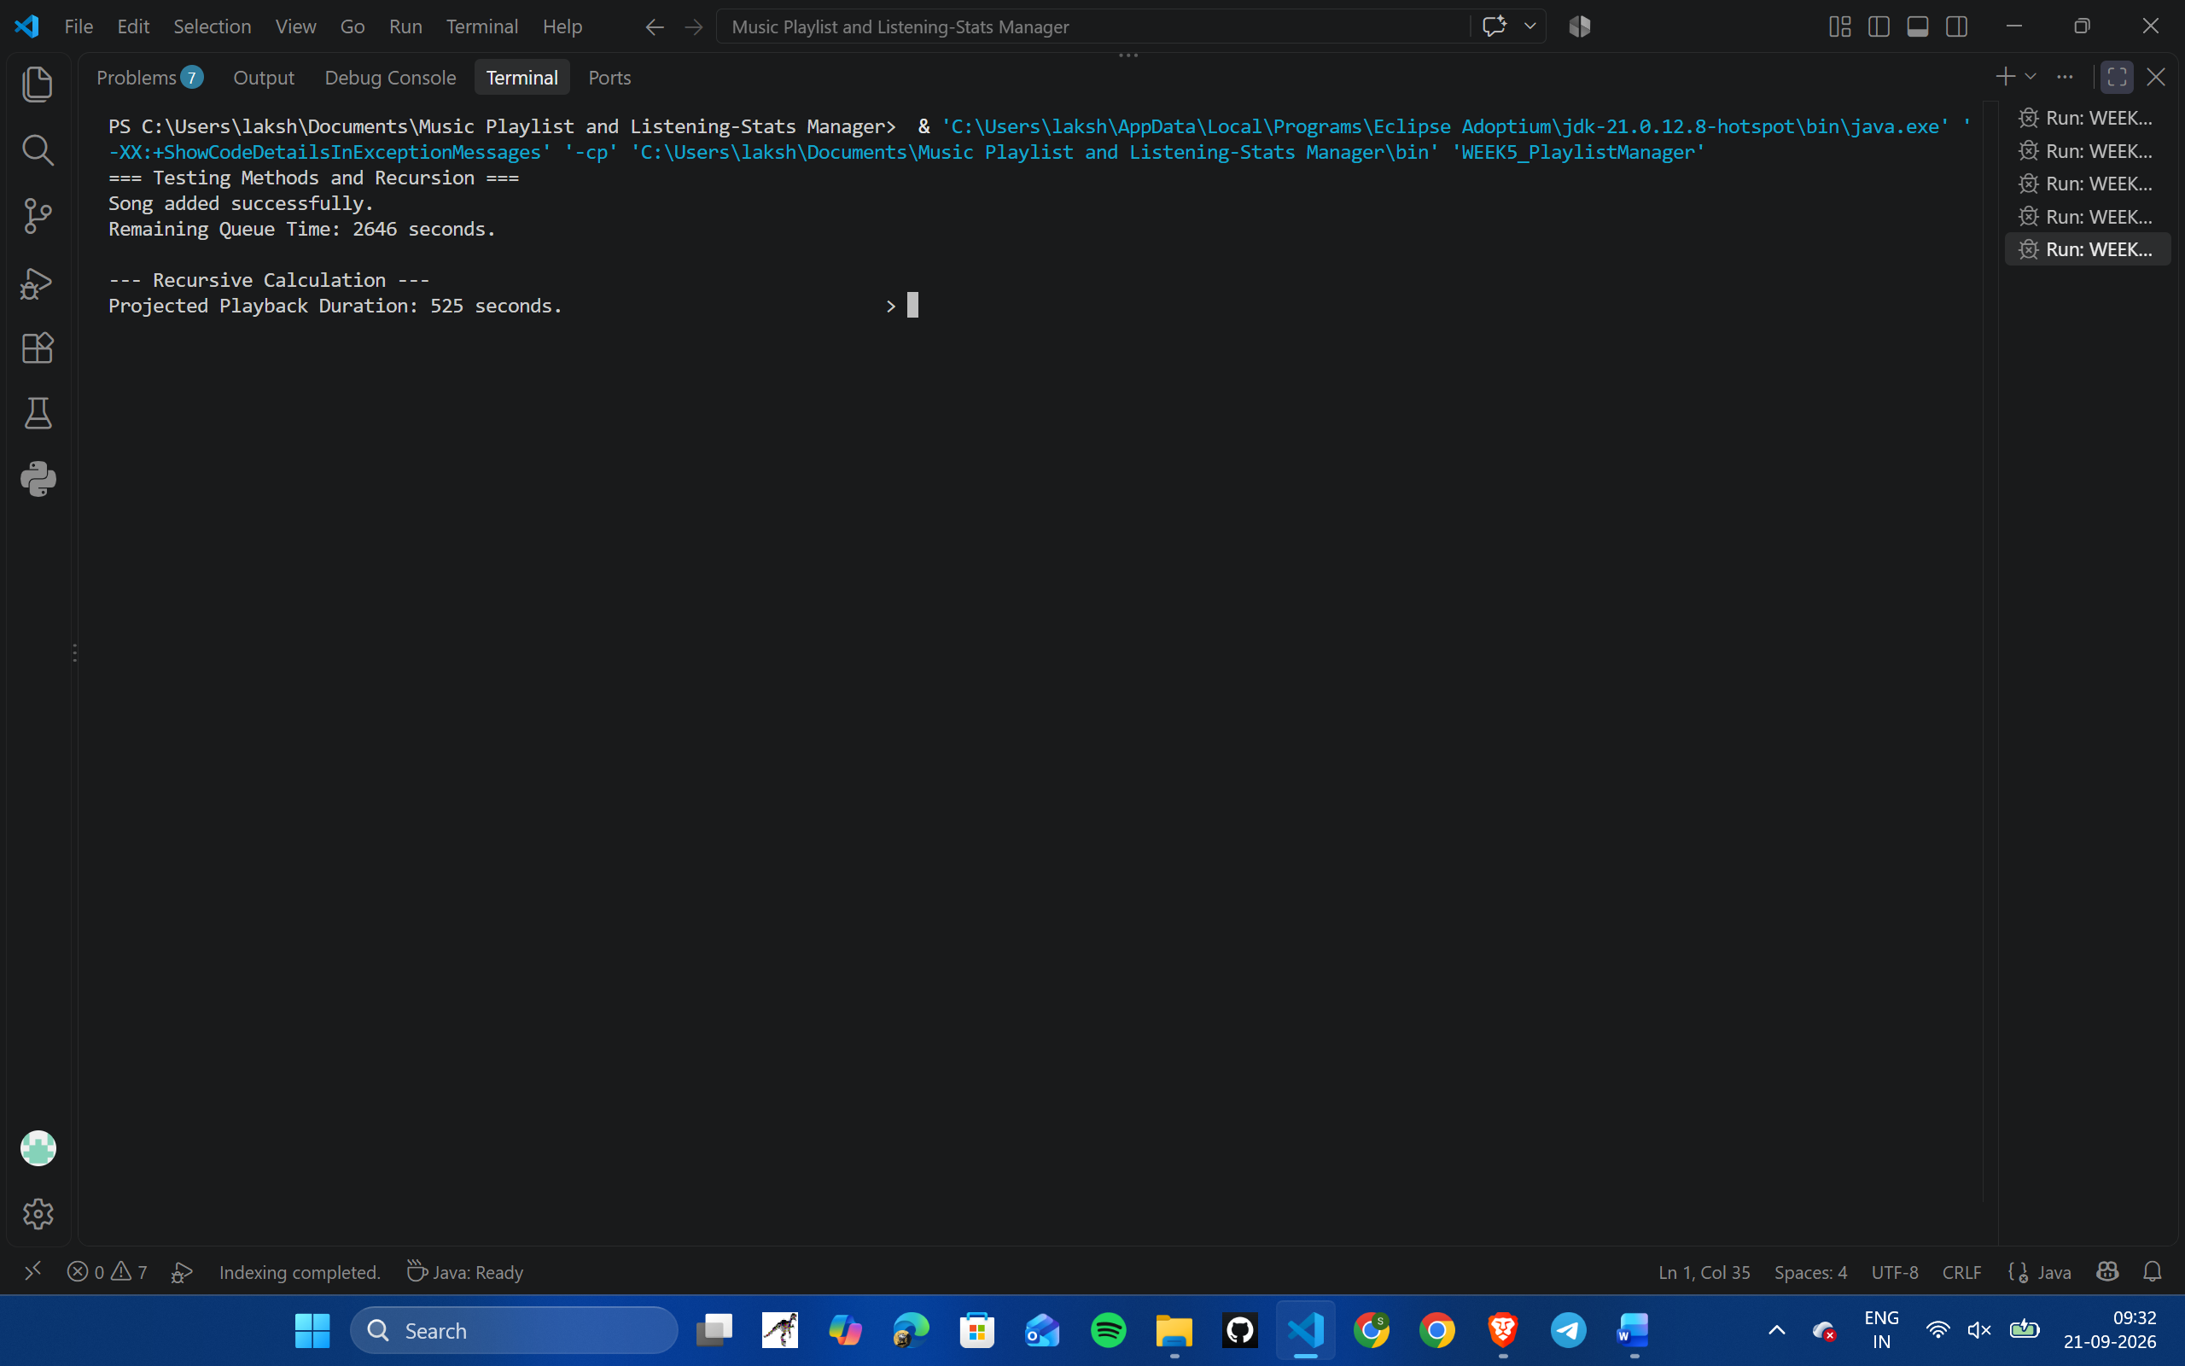

Week 6: Array Structures (Final Integrated Project)
- Concept: Using 1D and 2D arrays to store and manage multiple related values.
- Objective: Build the complete playlist manager combining all concepts from Week 1 to Week 6.
Code:

import java.util.Scanner;

public class Module3_Week6 {
private static final int MAX_SONGS = 5;
private static String[] titles = new String[MAX_SONGS];
private static int[] durations = new int[MAX_SONGS];
private static int[][] stats = new int[2][MAX_SONGS]; // Row 0: Play Count, Row 1: Total Played Time
private static int songCount = 0;

public static void printPlaylist() {
if (songCount == 0) {
System.out.println("Playlist is empty!");
return;
}
System.out.println("\n[PLAYLIST LIST]");
for (int i = 0; i < songCount; i++) {
System.out.println("Track [" + i + "]: " + titles[i] + " (" + durations[i] + "s)");
}
}

public static void printStats() {
if (songCount == 0) {
System.out.println("No stats available.");
return;
}
System.out.println("\n[PLAYBACK STATS]");
for (int i = 0; i < songCount; i++) {
System.out.println("-> " + titles[i] + " | Played: " + stats[0][i] + " times | Total Time: " + stats[1][i] + "s");
}
}

// Recursive sum of track lengths
public static int calculateTotalTime(int[] durationsArr, int index) {
if (index < 0) {
return 0;
}
return durationsArr[index] + calculateTotalTime(durationsArr, index - 1);
}

public static void main(String[] args) {
Scanner scanner = new Scanner(System.in);

// Initial sample data
titles[0] = "Bohemian Rhapsody";
durations[0] = 354;
songCount++;

titles[1] = "Hotel California";
durations[1] = 390;
songCount++;

int choice;
do {
System.out.println("\n=================================");
System.out.println(" MUSIC PLAYLIST & STATS SYSTEM ");
System.out.println("=================================");
System.out.println("1. View Playlist");
System.out.println("2. Play Song & Update Stats");
System.out.println("3. Calculate Total Time (Recursive)");
System.out.println("4. Exit");
System.out.print("Enter option (1-4): ");
choice = scanner.nextInt();

switch (choice) {
case 1:
printPlaylist();
break;
case 2:
printPlaylist();
if (songCount > 0) {
System.out.print("\nEnter song index to play (0 to " + (songCount - 1) + "): ");
int index = scanner.nextInt();
if (index >= 0 && index < songCount) {
stats[0][index] += 1;
stats[1][index] += durations[index];
System.out.println("Now Playing: " + titles[index]);
} else {
System.out.println("Invalid song index!");
}
}
printStats();
break;
case 3:
System.out.println("\n[TOTAL PLAYLIST TIME]");
if (songCount > 0) {
int total = calculateTotalTime(durations, songCount - 1);
System.out.println("Total playlist duration: " + total + " seconds.");
} else {
System.out.println("Playlist is empty.");
}
break;
case 4:
System.out.println("Exiting system. Have a great day!");
break;
default:
System.out.println("Invalid option! Try again.");
}
} while (choice != 4);

scanner.close();
}
}
Output Evidence: 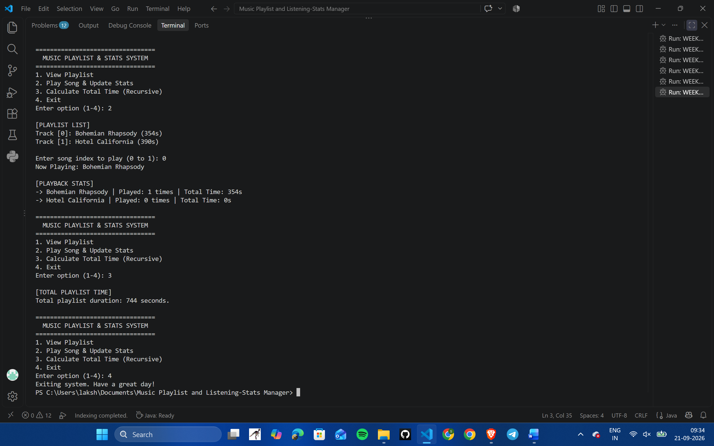

Advantages
- Automated Time Calculation: Eliminates the need to manually add song lengths to find total playlist time.
- Real-time User Tracking: The 2D array tracks play counts and total listened time automatically whenever a song plays.
- Easy to Use: Simple menu interface created using loops makes navigation straight to the point.
- Efficient Memory Usage: Simple Java array structures use minimal system memory and compile quickly.
- Error Prevention: Input validation prevents users from entering invalid song durations or menu selections.
Project Conclusion
This project successfully demonstrates how fundamental Java programming concepts can be used step-by-step to build a complete, real-world application. Moving from simple output statements and variable declarations in Module 1 to decision logic, menu loops, custom methods, and multi-dimensional arrays in Module 3 provided a comprehensive learning experience. The final application functions as an effective prototype for managing track lists and tracking listening statistics, showing how foundational programming techniques can be integrated into a useful digital utility.

